**Visvesvaraya Technological University Belagavi-590 018, Karnataka**

A Mini Project Report on

**“Online Photo Shopping”**

**Mini Project Report submitted in partial fulfilment of the requirement for the**

**DBMS Laboratory with Mini Project [18CSL58]**  **Bachelor of Engineering**

In

**Artificial Intelligence and Machine Learning**

**Submitted by**

**Jagruthi G 1JT20AI013**

****Vaibhavi B Raj 1JT20AI047**

**Department of Artificial Intelligence and Machine learning**

**Jyothy Institute of Technology Tataguni, Bengaluru-560082**

**Jyothy Institute of Technology**

**Tataguni, Bengaluru-560082**

**Department of Artificial Intelligence and Machine learning**

### CERTIFICATE

Certified that the mini project work entitled **“Online Photo shopping” carried** out by **Jagruthi G [1JT20AI013] and Vaibhavi B Raj [1JT20AI047]** bona-fide students of Jyothy Institute of Technology, in partial fulfilment for the award of **Bachelor of Engineering Artificial Intelligence and Machine Learning** in department of the **Visvesvaraya Technological University, Belagavi** during the year **2022-2023**. It is certified that all corrections/suggestions indicated for Internal Assessment have been incorporated in the Report deposited in the departmental library. The project report has been approved as it satisfies the academic requirements in respect of Project work prescribed for the said Degree.

Guide Signature: Signature of HOD:

**Mrs Soumya K N Dr.Madhu B R**

Assistant Professor Professor and HOD

Dept. of AIML Dept. of AIML

JIT, Bengaluru JIT, Bengaluru

External Viva Examiner Signature with Date:

1.

2.

**ACKNOWLEDGEMENT**

Firstly, we are very grateful to this esteemed institution **“Jyothy Institute of Technology”**for providing us an opportunity to complete our project.

We express our sincere thanks to our Principal **Dr. Gopalakrishna K** for providing us with adequate facilities to undertake this project.

We would like to thank **Dr.Madhu B R**, Professor and Head of AIML and Engineering Department for providing his valuable support.

We would like to thank our guides **Mrs. Sowmya K N**, Assistant Professor for their keen interest and guidance in preparing this work.

Finally, we would thank all our friends who have helped us directly or indirectly in this project.

**Jagruthi G [1JT20AI013]**

**Vaibhavi B Raj [1JT20AI047]**

**ABSTRACT**

# This project is a web based shopping system for an existing shop. The project objective is to deliver the online shopping application into android platform. This project is an attempt to provide the advantages of online shopping to customers of a real shop. It helps buying the products in the shop anywhere through internet by using an android device. Thus the customer will get the service of online shopping and home delivery from his favourite shop. This system can be implemented to any shop in the locality or to multinational branded shops having retail outlet chains.

# If shops are providing an online portal where their customers can enjoy easy shopping from anywhere, the shops won’t be losing any more customers to the trending online shops such as flip kart or eBay.

# Since the application is available in the Smartphone it is easily accessible and always available.

**TABLE OF CONTENTS**

1. **INTRODUCTION……………………………………6-8**
   1. INTRODUCTION TO DBMS……………………………7
   2. INTRODUCTION TO SQL 7
   3. INTRODUCTION TO PANDEMIC DATABASE………8
   4. SCOPE AND IMPORTANCE OF WORK 8

2.DESIGN……………………………………………....9-15

2.1. THEORY OF ER DIAGRAM… 10

2.2. ENTITIES… 11

* 1. RELATIONSHIPS… 11
  2. ATTRIBUTES… 12
  3. ER DIAGRAM 13
  4. SCHEMA DIAGRAM… 14
  5. LIST OF TABLES ………………15

3.IMPLEMENTATION……………………………...16-25

3.1. TABLE CREATION………………………………....17-19

3.2. TABLE DESCRIPTION……………………………...19-22

3.3. QUERIES………………………...…………………..23-26

4.RESULTS AND SNAPSHOTS…………………..........27-37

5.CONCLUSION…………………………………………38-40

5.1. FEATURES… ..39

* 1. REFERENCES .40

# 

# CHAPTER-1

# INTRODUCTION

## INTRODUCTION TO DBMS:

A database management system refers to technology for creating and managing databases. DBMS is a software tool to organize (create, retrieve, update and manage) data in a database.

The main aim of DBMS is to supply a way to store up and retrieve database information that is both convenient and efficient.

Advantages of databases:

* + - To develop software applications in less time.
    - Data independence and efficient use of data.
    - For uniform data administration.
    - For data integrity and security.
    - To use user-friendly declarative query language.

## INTRODUCTION TO SQL:

SQL is an abbreviation of structured query language, is a language to request data from a database, to add, update, remove data within a database, or to manipulate the metadata of the database.

SQL is a declarative language in which the expected result or operation is given without the specific details about how to accomplish the task. The steps required to execute SQL statement are handled transparently by the SQL database. Sometimes SQL is characterised as non-procedural because procedural language generally require the details of the operations to be specified, such as opening and closing tables, loading and searching indexes, or flushing buffers and writing data to file system. Therefore, SQL is considered to be designed at a higher conceptual level of operation than procedural languages because the lower level logical and physical operation aren’t specified and are determined the SQL engine or server process that executes it.

## INTRODUCTION TO ONLINE PHOTO SHOPPING:

This project is a web-based shopping system for an existing shop. The project objective is to deliver the online photo shopping application into an android and website platform. Online shopping is the process whereby consumers directly buy goods or services from a seller in real-time, without an intermediary service, over the web. It is a form of electronic commerce. This project is an attempt to provide the advantages of online photo shopping to customers of a real shop. It helps buy the products in the shop from anywhere through the web by using an android device and personal computers. Thus the customer will get the service of online photo shopping and home delivery from his favorite shop.

## SCOPE AND IMPORTANCE OF WORK:

The scope of the project is clear to give as implemented and attractive application to simplify the work as well as to reduce the efforts while doing it offline or we can say by doing with old methods.

This system can be implemented to any shop in the locality or to multinational branded shops having retail outlet chains. The system recommends a facility to accept the orders 24*7 and a home delivery system which can make customers happy. If shops are providing an online portal where their customers can enjoy easy shopping from anywhere, the shops won’t be losing any more customers to the trending online shops such as flip kart or ePay. Since the application is available in the Smartphone it is easily accessible and always available.

# CHAPTER-2

# DESIGN

* 1. **THEORY OF ER DIAGRAM**

An Entity–relationship model (ER model) describes the structure of a database with the help of a diagram, which is known as Entity Relationship Diagram (ER Diagram).

An ER model is a design or blueprint of a database that can later be implemented as a database. The main components of E-R model are: entity set and relationship set.

An ER diagram shows the relationship among entity sets. An entity set is a group of similar entities and these entities can have attributes. In terms of DBMS, an entity is a table or attribute of a table in database, so by showing relationship among tables and their attributes, ER diagram shows the complete logical structure of a database.

ER model allows you to draw Database Design It is an easy to use graphical tool for modeling data Widely used in Database Design Helps you to define terms related to entity relationship modeling Provide a preview of how all your tables should connect, what fields are going to be on each table.

ER diagrams are translatable into relational tables which allows you to build databases quickly ER diagrams can be used by database designers as a blueprint for implementing data in specific software applications

**Symbols Used in ER Diagrams**

**Rectangle**: Represents Entity sets.

**Ellipses:** Attributes.

**Diamonds**: Relationship Set.

**Lines:** They link attributes to Entity Sets and Entity sets to Relationship Set.

**Double Ellipses:** Multivalued Attributes .

**Dashed Ellipses:** Derived Attributes.

**Double Rectangles:** Weak Entity Sets.

**Double Lines:** Total participation of an entity in a relationship set.

The ER model is a high-level data model diagram. ER diagrams are a visual tool which is helpful to represent the ER model There may be various valid approaches to an ER diagram. You need to make sure that the ER diagram supports all the data you need to store

**Components of ER Diagram**

ER diagram has three main components:

1. Entity

2. Attribute

3. Relationship

## ENTITIES:

## An entity is an 'object' in the real world with an independent existence and an entity type defines a collection (or set) of entities that have the same attributes. Each entity type in the database is described by its name and attributes.

## An entity type is represented in ER diagrams as a rectangular box enclosing the entity type name.

## An entity that cannot be uniquely identified by its own attributes and relies on the relationship with other entity is called weak entity.

## The weak entity is represented by a double rectangle. For example a bank account cannot be uniquely identified without knowing the bank to which the account belongs, so bank account is a weak entity.

## RELATIONSHIPS

## A relationship among two or more entities represents an association among the entities and whenever an attribute of one entity refers to another entity, there exists a relationship between the two entities.

## In a relationship, a foreign key of one table refers the primary key of the other table and it is represented by diamond shape in ER diagram.

## A relationship is represented by diamond shape in ER diagram, it shows the relationship among entities. There are four types of cardinal relationships:

## 1. One to One

## 2. One to Many

## 3. Many to One

## 4. Many to Many

## One to One Relationship: When a single instance of an entity is associated with a single instance of another entity then it is called one to one relationship.

## One to Many Relationship: When a single instance of an entity is associated with more than one instances of another entity then it is called one to many relationship.

## Many to One Relationship: When more than one instances of an entity is associated with a single instance of another entity then it is called many to one relationship.

## Many to Many Relationship: When more than one instances of an entity is associated with more than one instances of another entity then it is called many to many relationship.

## ATTRIBUTES

## An attribute represents some property of interest that further describes an entity and he column header of the table shows the attributes. Each attribute in a table has a certain domain which allows it to accept a certain ‘set of values’ only.

## The attribute values, of each entity, will define its characteristics in the table and is represented by oval in the ER diagram.

## There are four types of attributes:

## 1. Key attribute

## 2. Composite attribute

## 3. Multivalued attribute

## 4. Derived attribute

## Key attribute: A key attribute can uniquely identify an entity from an entity set.

## Composite attribute: An attribute that is a combination of other attributes is known as composite attribute.

## Multivalued attribute: An attribute that can hold multiple values is known as multivalued attribute. It is represented with double ovals in an ER Diagram.

## Derived attribute: A derived attribute is one whose value is dynamic and derived from another attribute. It is represented by dashed oval in an ER Diagram.

.

# ER DIAGRAM

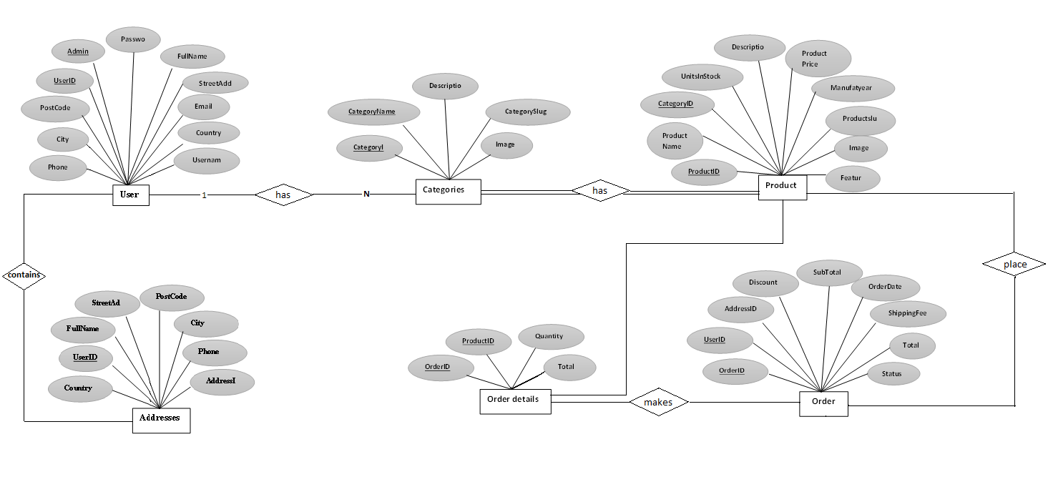

Figure **2.4.1.** **ER-diagram for** **Studio Online shopping**

# SCHEMA DIAGRAM

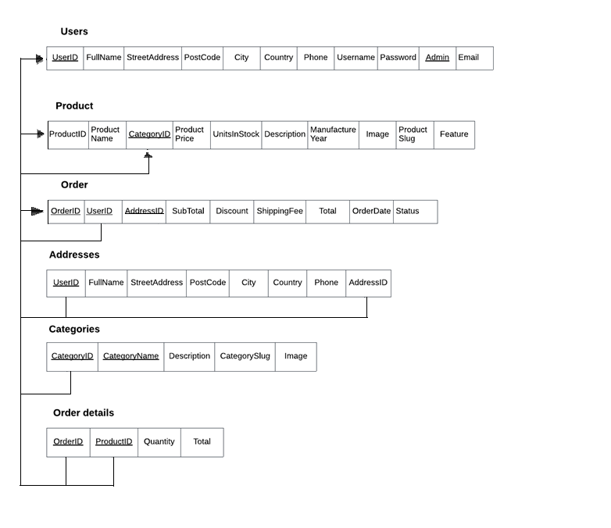

Figure **2.5.2. schema diagram for studio online shopping system**

**LIST OF TABLES:**

**1.User:** Stores user information such as name, email, and password.

**2. Categories:** Stores the categories that expenses can be classified into for each user, including the user ID and category name**.**

**3. Product:** Stores information about products available for purchase, including the name, description, price, image, and stock level.

**4. Order:** Stores information about orders placed by customers, including the customer ID and the total price of the order.

**5. Order details:** Stores information about the items in an order, including the order ID, product ID, and quantity.

**6. Addresses:** Stores the user addresses of the information.

# CHAPTER-3

**IMPLEMENTATION & QUERIES**

**3.1. IMPLEMENTATION**

**(i)Table creation: -**

CREATE TABLE `addresses` (

`UserID` int(11) DEFAULT NULL,`FullName` varchar(50) NOT NULL,`StreetAddress` varchar(255) NOT NULL,`PostCode` varchar(6) NOT NULL,`City` varchar(28) NOT NULL,`Country` varchar(28) NOT NULL,`Phone` varchar(12) NOT NULL,`AddressID` int(11) NOT NULL

)

CREATE TABLE `categories` (

`CategoryID` int(11) NOT NULL,`CategoryName` varchar(58) NOT NULL,`Description` mediumtext DEFAULT NULL,`CategorySlug` varchar(68) NOT NULL,`Image` varchar(58) NOT NULL

)

CREATE TABLE `order details` (

`OrderID` int(11) NOT NULL,`ProductID` int(11) NOT NULL, `Quantity` smallint(2) NOT NULL DEFAULT 1,`Total` decimal(10,2) NOT NULL

)

CREATE TABLE `orders` (

`OrderID` int(11) NOT NULL,`UserID` int(11) NOT NULL,`AddressID` int(11) NOT NULL,`SubTotal` decimal(10,2) DEFAULT NULL, `Discount` decimal(10,2) DEFAULT NULL,`ShippingFee` decimal(10,2) DEFAULT NULL,`Total` decimal(10,2) DEFAULT NULL,`OrderDate` datetime DEFAULT NULL,`Status` varchar(150) NOT NULL

)

CREATE TABLE `products` (

`ProductID` int(11) NOT NULL,`ProductName` varchar(40) NOT NULL, `CategoryID` int(11) DEFAULT NULL,`ProductPrice` decimal(10,2) DEFAULT 0.00,`UnitsInStock` smallint(5) DEFAULT 0,`Description` varchar(255) NOT NULL,`ManufactureYear` smallint(5) NOT NULL,`Image` varchar(50) NOT NULL,`ProductSlug` varchar(50) NOT NULL,`Feature` tinyint(1) NOT NULL DEFAULT 0

)

CREATE TABLE `users` (

`UserID` int(11) NOT NULL,`FullName` varchar(50) NOT NULL,`StreetAddress` varchar(255) NOT NULL,`PostCode` varchar(6) NOT NULL,`City` varchar(28) NOT NULL,`Country` varchar(28) NOT NULL, `Phone` varchar(12) NOT NULL,`Email` varchar(50) NOT NULL, `Username` varchar(28) DEFAULT NULL,`Password` varchar(158) DEFAUL NULL, `Admin` tinyint(1) NOT NULL DEFAULT 0

)

ALTER TABLE `addresses`

ADD PRIMARY KEY (`AddressID`);

Indexes for table `categories`

ALTER TABLE `categories`

ADD PRIMARY KEY (`CategoryID`),

ADD UNIQUE KEY `CategoryID` (`CategoryID`);

Indexes for table `products`

ALTER TABLE `products`

ADD PRIMARY KEY (`ProductID`),

ADD KEY `ProductID` (`ProductID`);

AUTO_INCREMENT for dumped tables

AUTO_INCREMENT for table `addresses`

ALTER TABLE `addresses`

MODIFY `AddressID` int(11) NOT NULL AUTO_INCREMENT, AUTO_INCREMENT=7;

AUTO_INCREMENT for table `categories`

ALTER TABLE `categories`

MODIFY `CategoryID` int(11) NOT NULL AUTO_INCREMENT, AUTO_INCREMENT=6;

AUTO_INCREMENT for table `products`

ALTER TABLE `products`

MODIFY `ProductID` int(11) NOT NULL AUTO_INCREMENT, AUTO_INCREMENT=18;

**3.2. Table Descriptions**

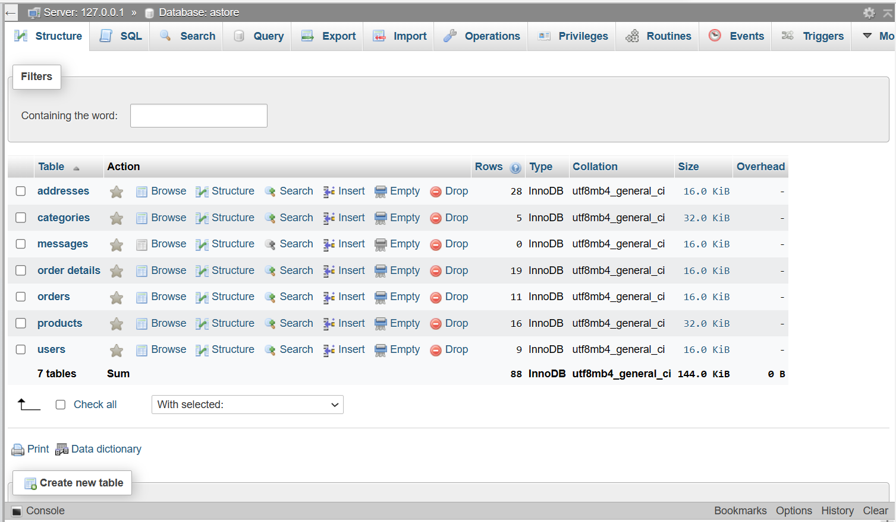 **FIGURE ( i ) – Users**

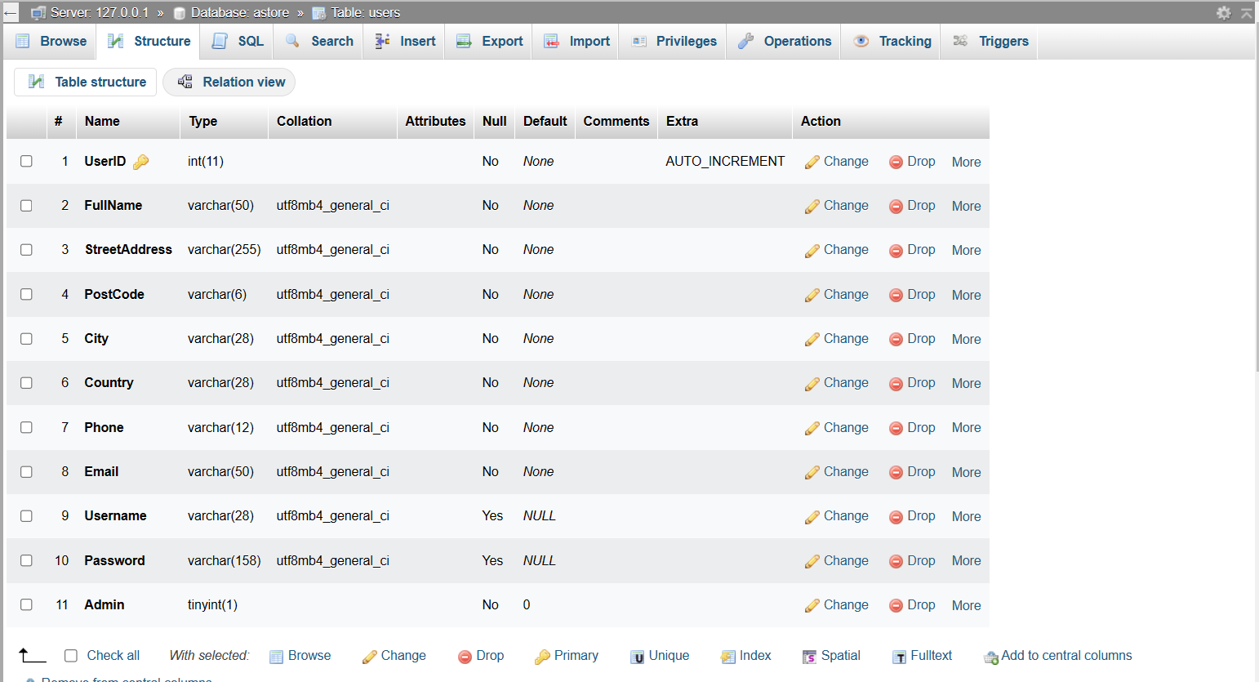

**FIGURE ( ii ) – Products**

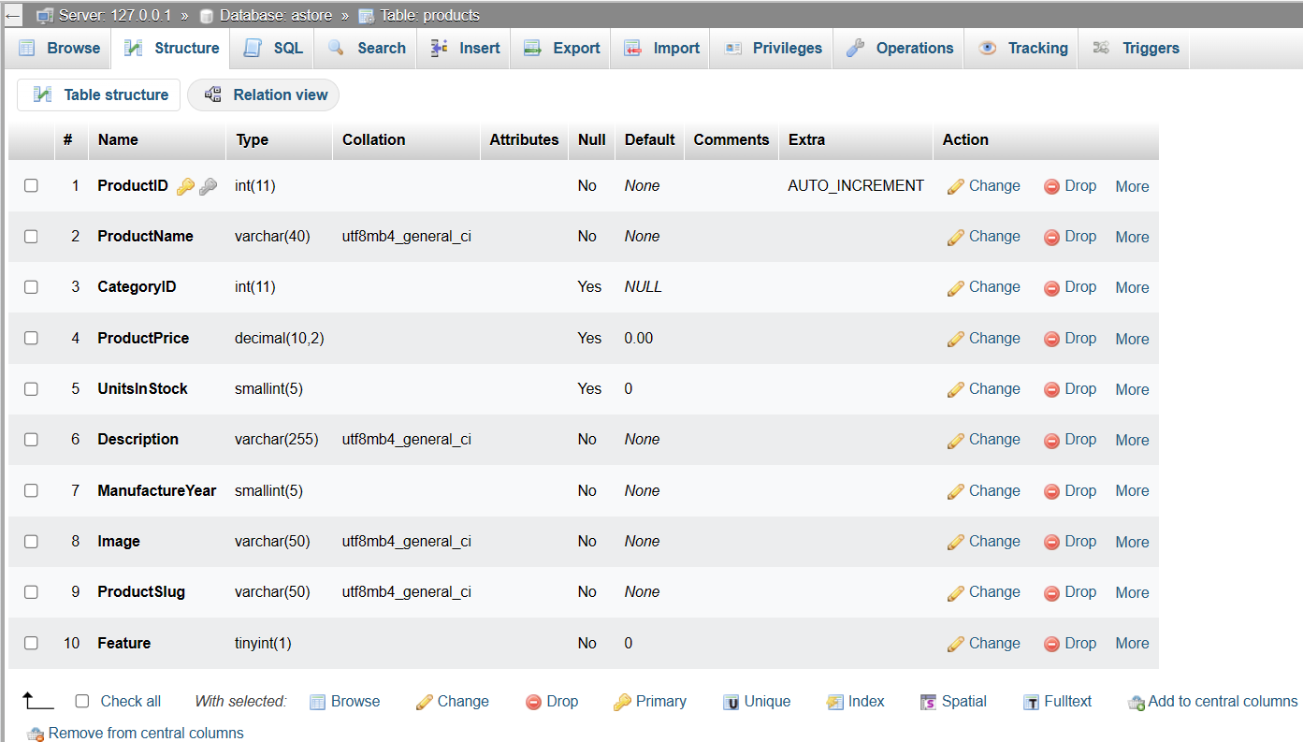

**FIGURE ( iii ) – Category**

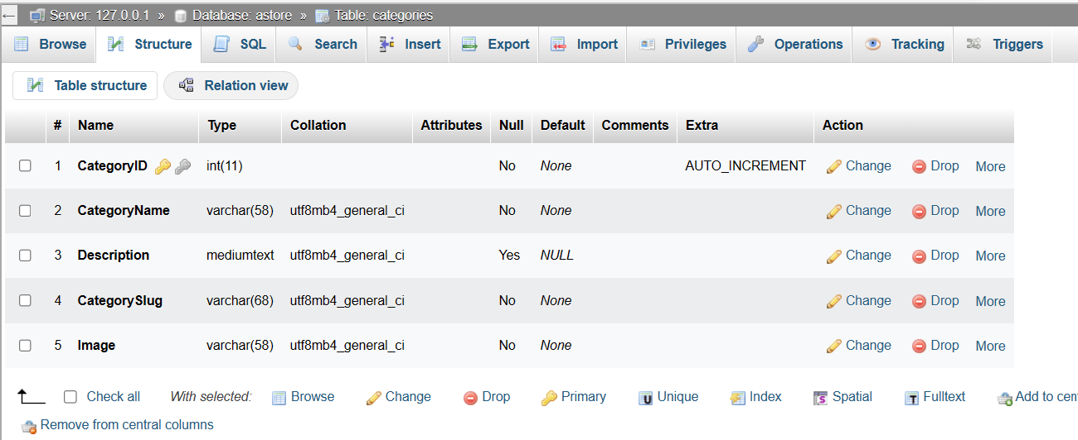

**FIGURE ( iv ) – Order_details**

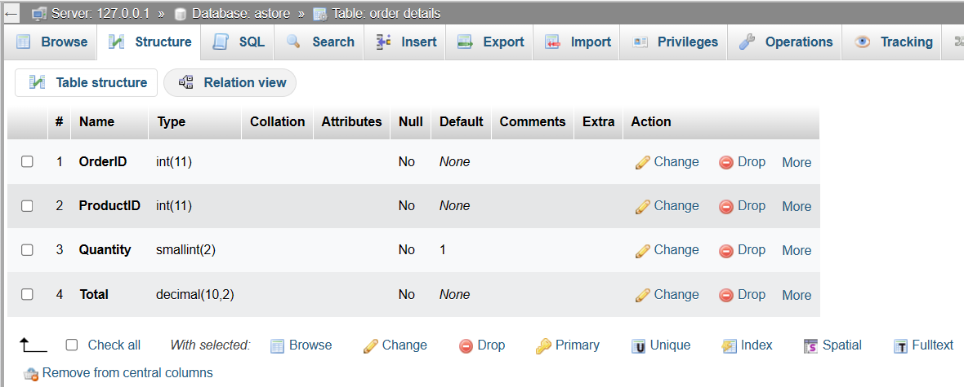

**FIGURE ( v ) – Orders**

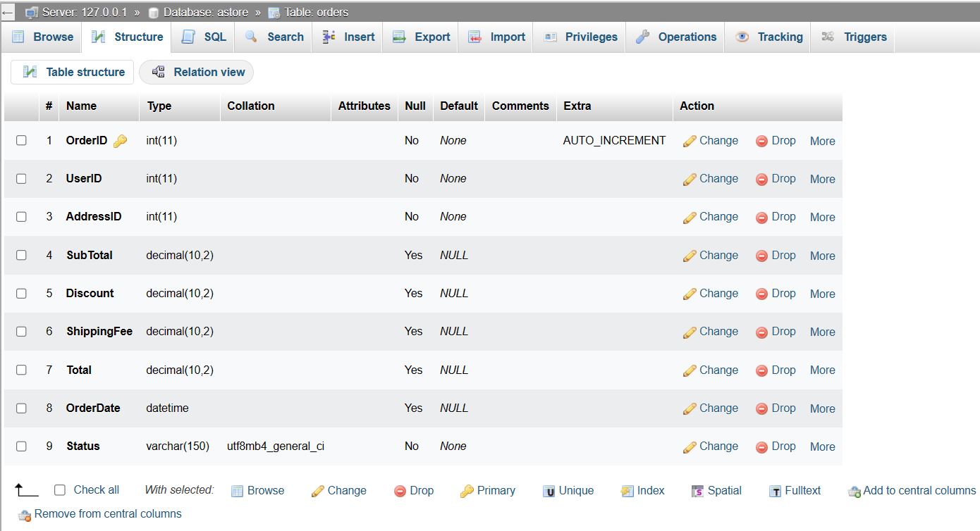 **FIGURE ( vi ) – Addresses**

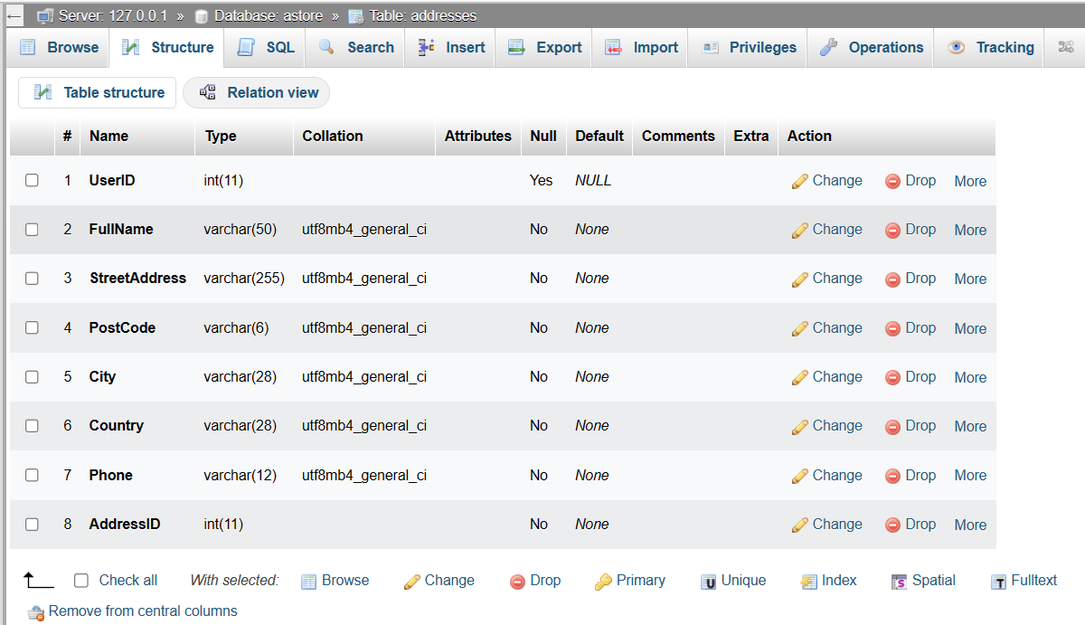

# 3.3. QUERIES SNAPSHOT

## QUERY - 1:

Retrieve a list of all categories and their associated details:

SELECT * FROM categories;

**Output:**

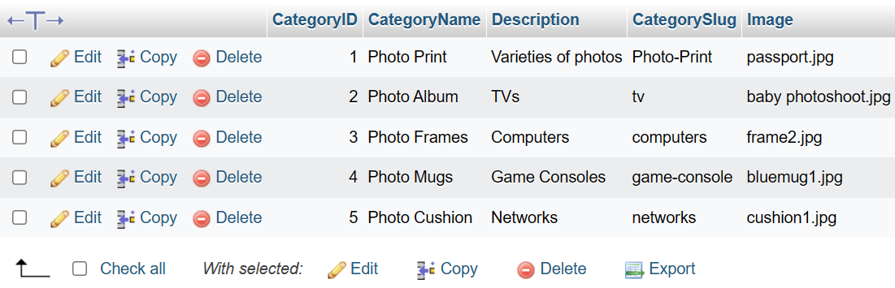

**Figure 3.3.1.query-1 output**

## QUERY - 2:

Retrieve the name, price, and description of all products in a specific category:

SELECT ProductName, ProductPrice, Description

FROM products

WHERE CategoryID = 5;

**Output:**

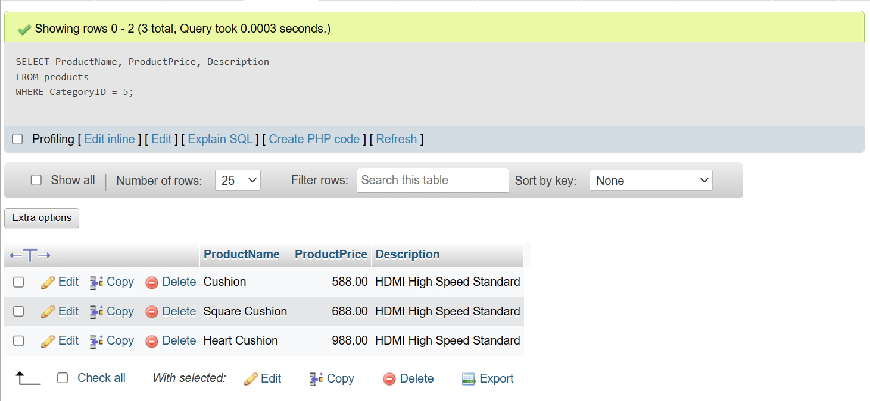

**Figure 3.3.2. query-2 output**

## QUERY - 3:

## Retrieve the name, email, and phone number of all users who have made an order:

## 

## SELECT FullName, Email, Phone

## FROM users

## JOIN orders

## ON users.UserID = orders.UserID;

**Output:**

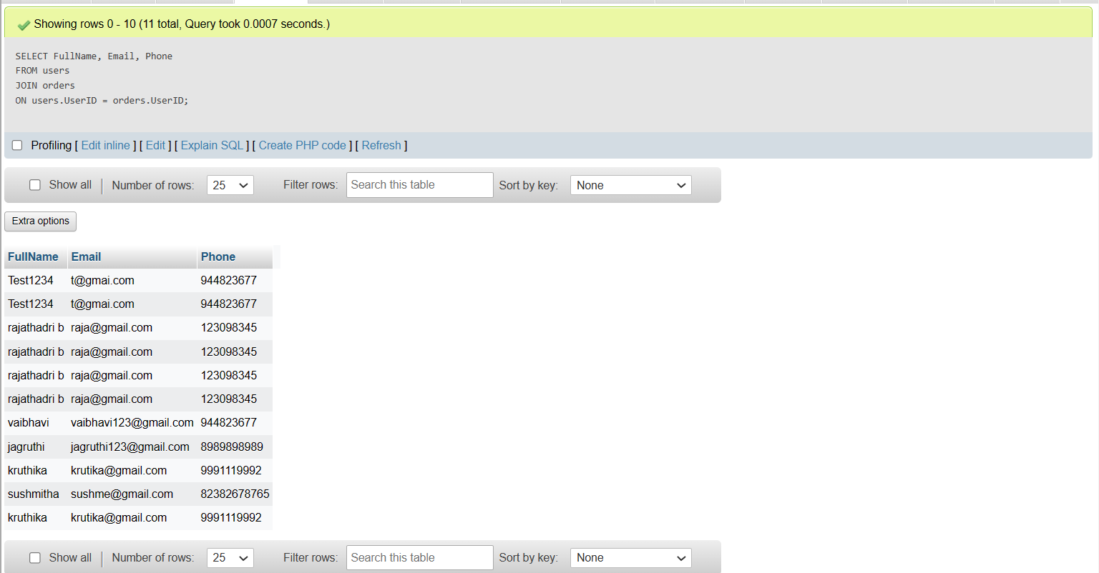

**Figure 3.3 .3query-3 output**

## QUERY - 4:

Get all products in the category “Photo Print”

SELECT * FROM products JOIN categories ON products.CategoryID = categories.CategoryID WHERE categories.CategoryName = “Photo Print”;

**Output:**

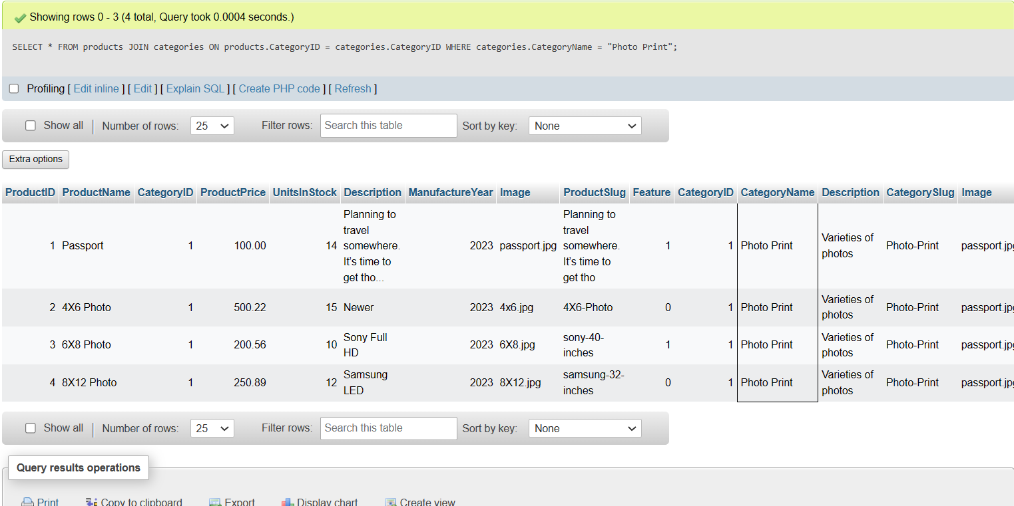

**Figure 3.3.4 query-4 output**

## QUERY - 5:

Get all total amount spent by each user

SELECT UserID,SUM(Total) as TotalSpent FROM orders GROUP BY UserID;

**Output:**

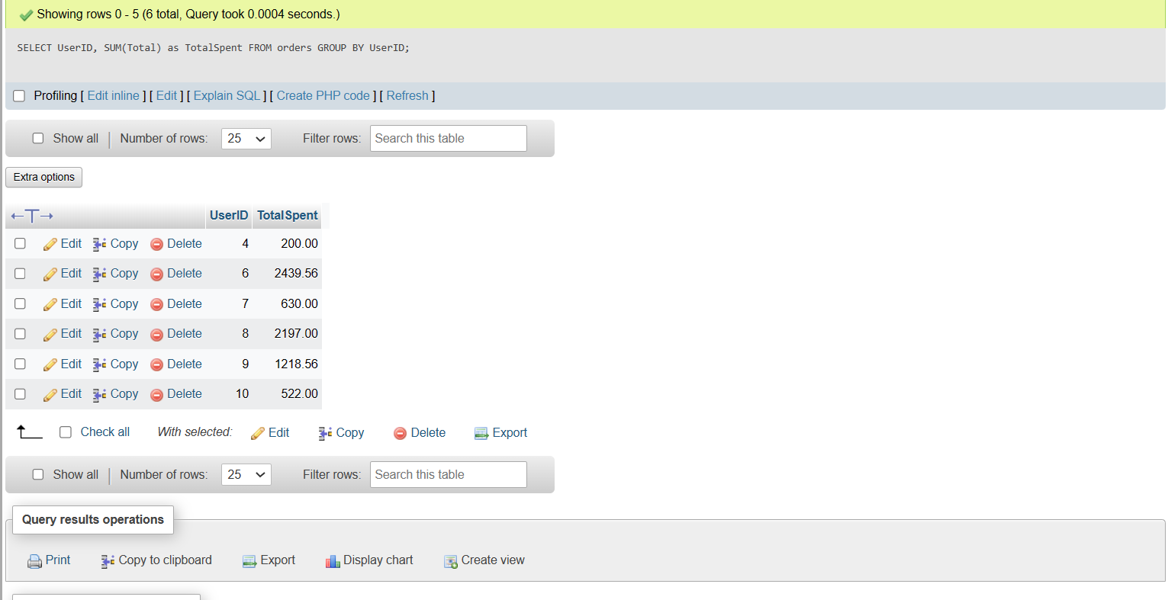

**Figure 3.3.5 query-5 output**

**QUERY – 6:**

Get the total quantity of each product in all orders

SELECT ProductID, SUM(Quantity) as TotalQuantity FROM `order details` GROUP BY ProductID;

**Output:**

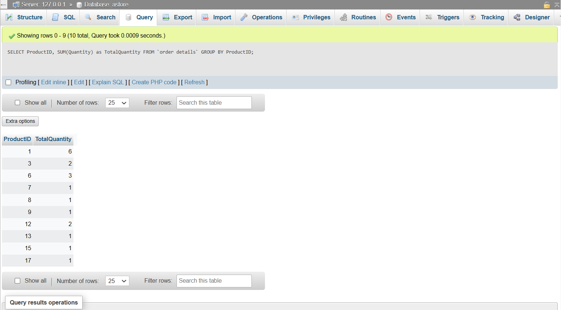

**Figure 3.3.6 query-6 output**

**CHAPTER-4**

**RESULT AND SNAPSHOT**

**4.1.LOGIN FORMS:**

## HOME PAGE:

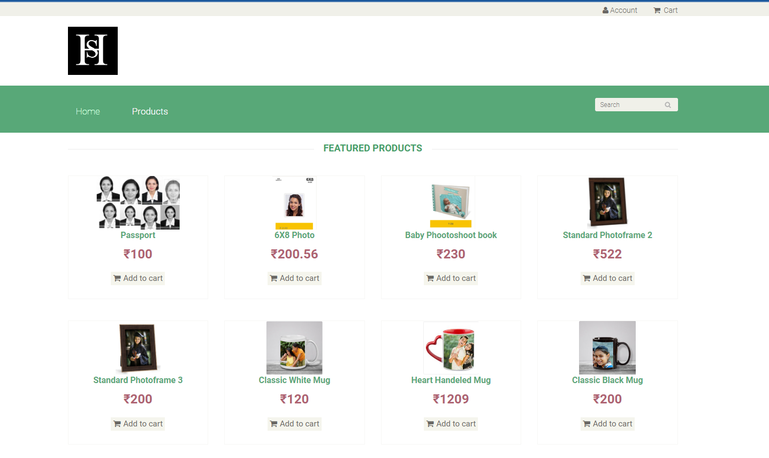

**Figure 4.1.1. home page**

## PRODUCTS PAGE:

## Figure 4.1.2. product page

## USER LOGIN PAGE:

## 

## Figure 4.1.3. user login page

## USER SIGN UP PAGE:

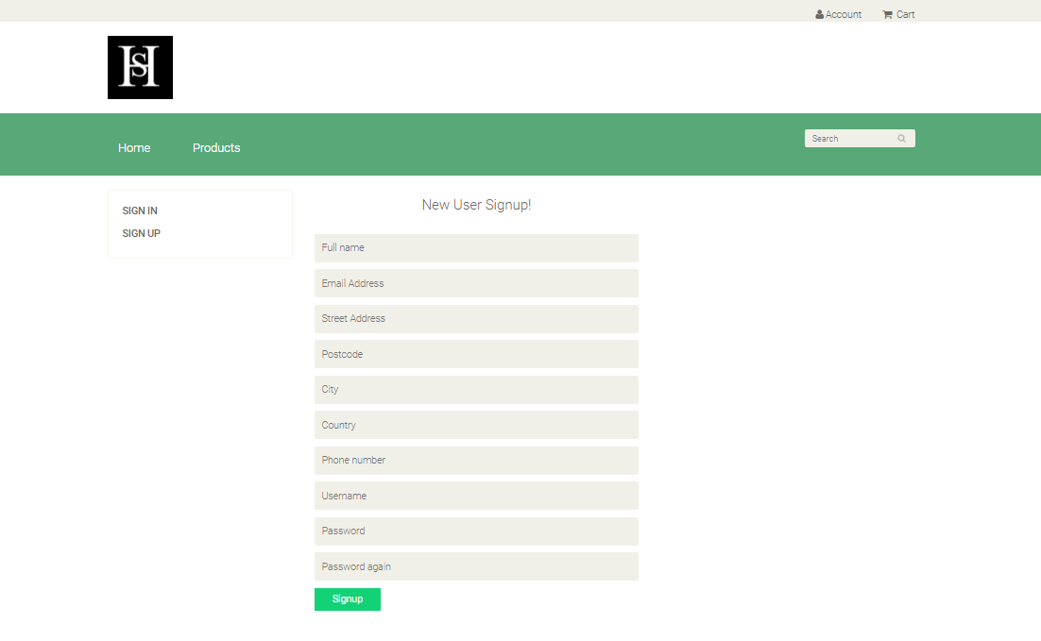

**Figure 4.1.4. user sign up page**

**4.2.ADMIN PAGE:**

**OPERATION ADMIN PAGE:[CATEGORIES]*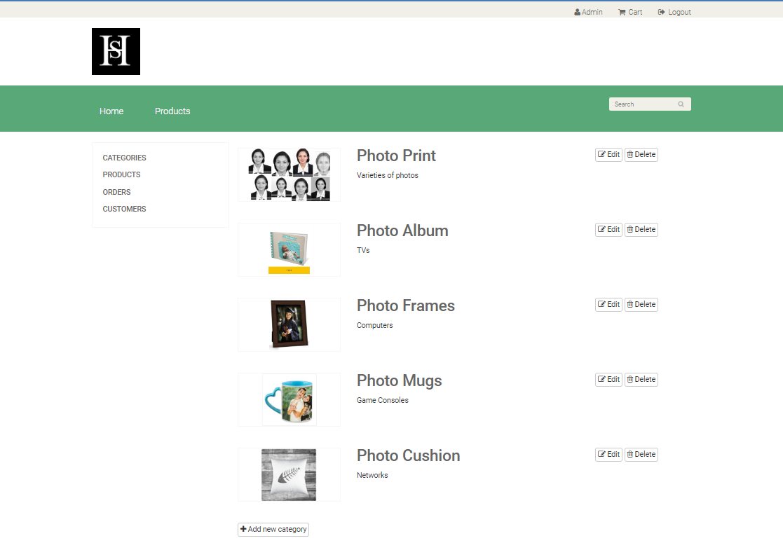***

**Figure 4.2.1.operation admin page**

## ADMIN PRODUCT PAGE:

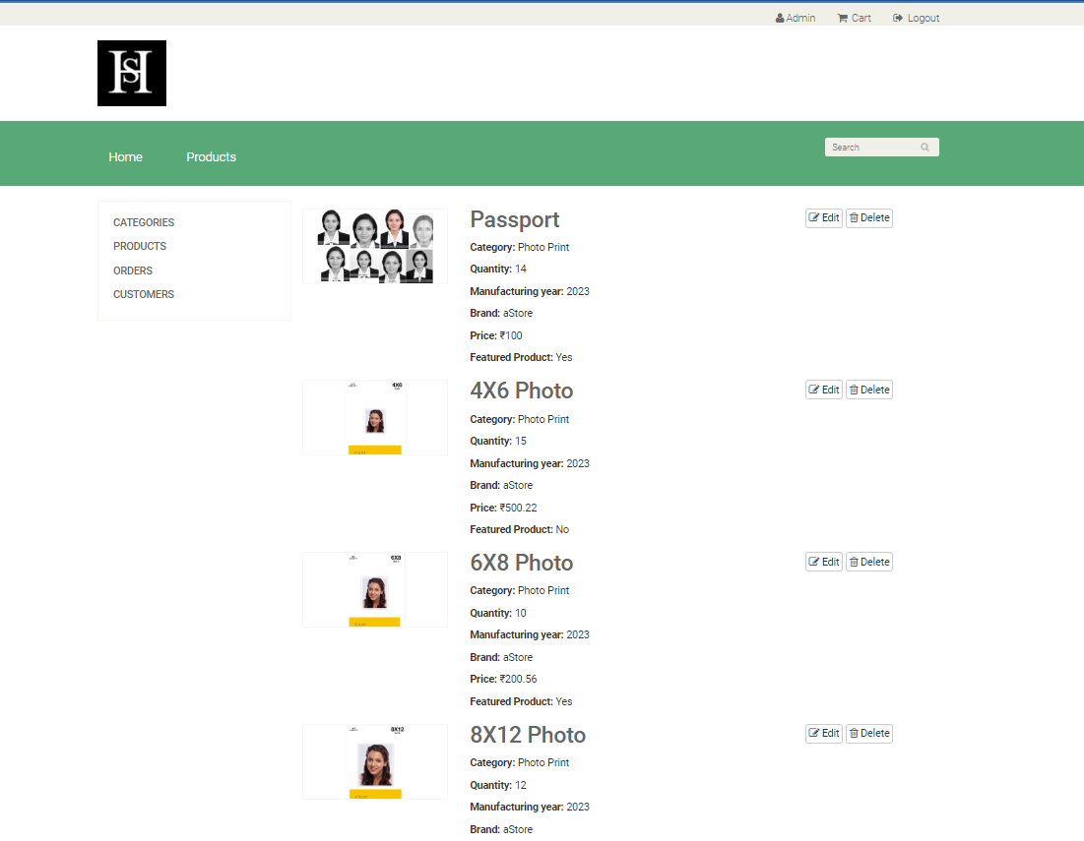

**Figure 4.2.2.admin product page**

**USER ORDERS ADMIN VIEW PAGE:**



**Figure 4.2.3. user orders admin view page**

## ADMIN PAGE:[ABOUT CUSTOMERS ]

## 

## Figure 4.2.4.admin page of customers

**ADMIN HOME PAGE:**

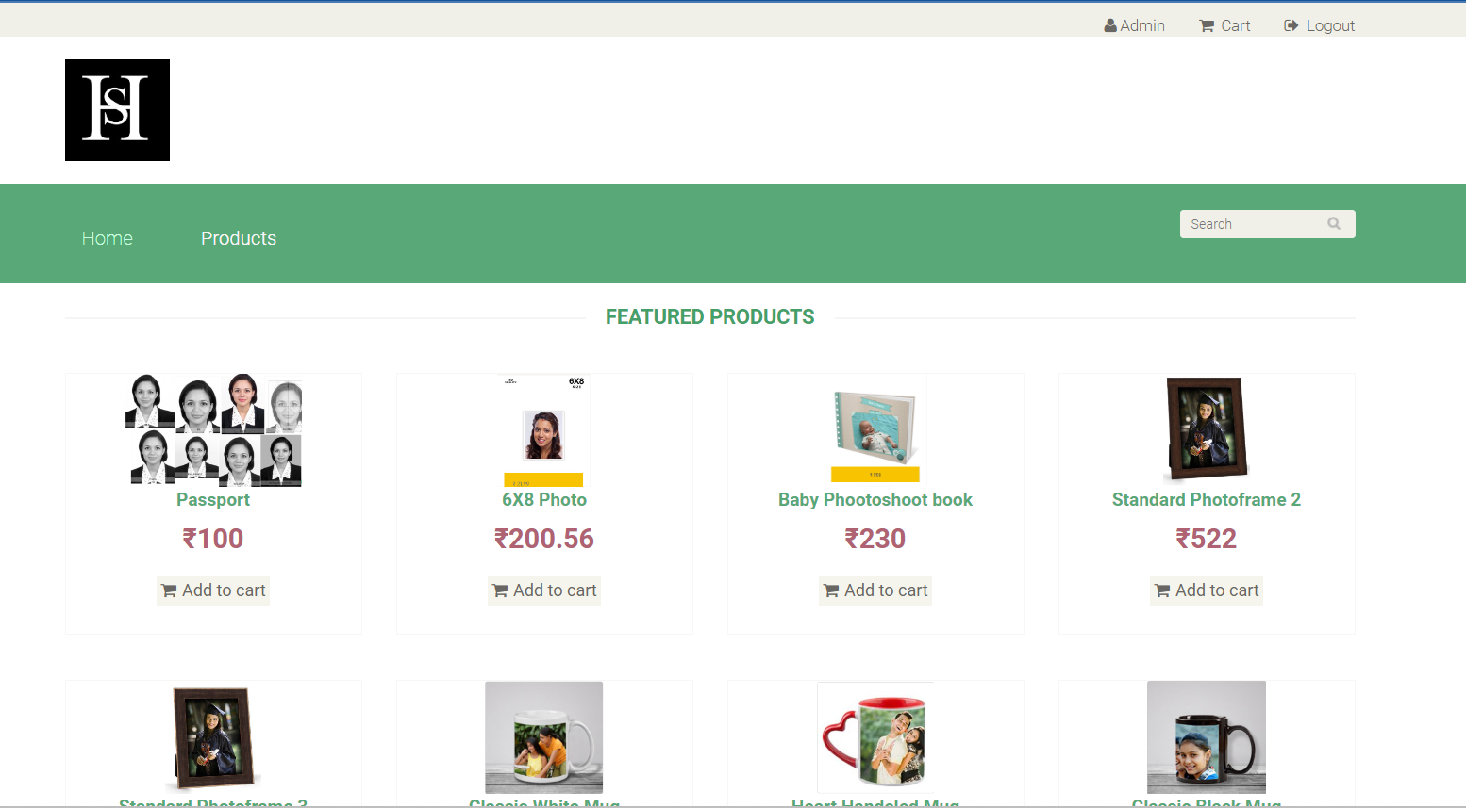

**Figure 4.2.5.admin home page**

## ADMIN ADD NEW CATEGORY / PRODUCT PAGE:

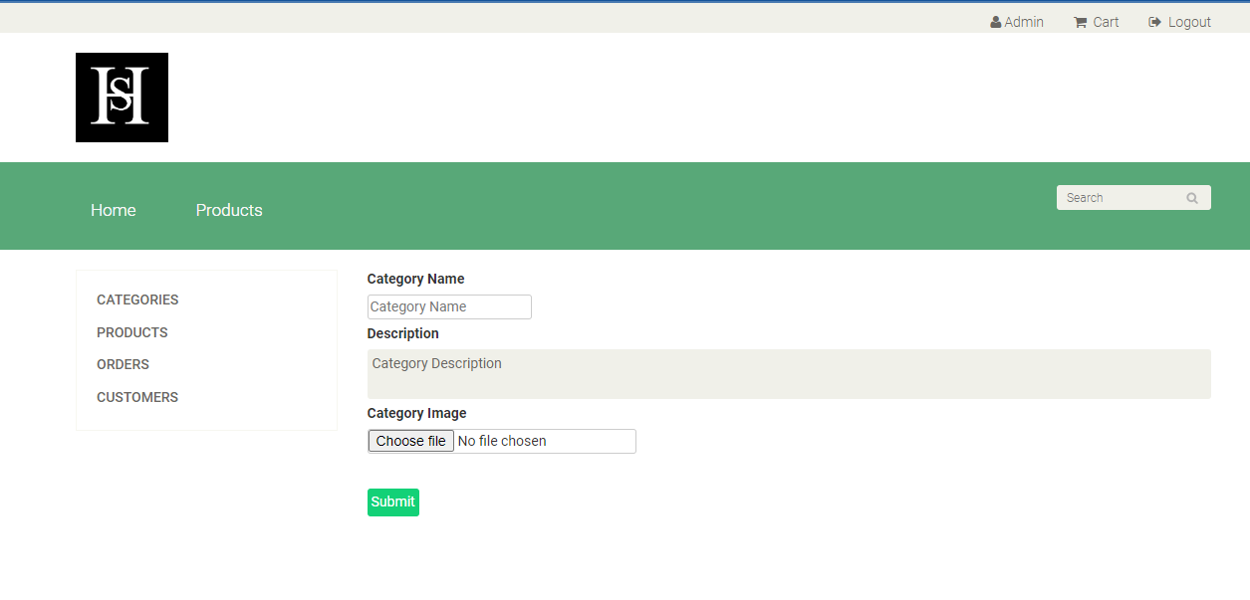

**Figure 4.2.6.(a)admin add new category/product page**

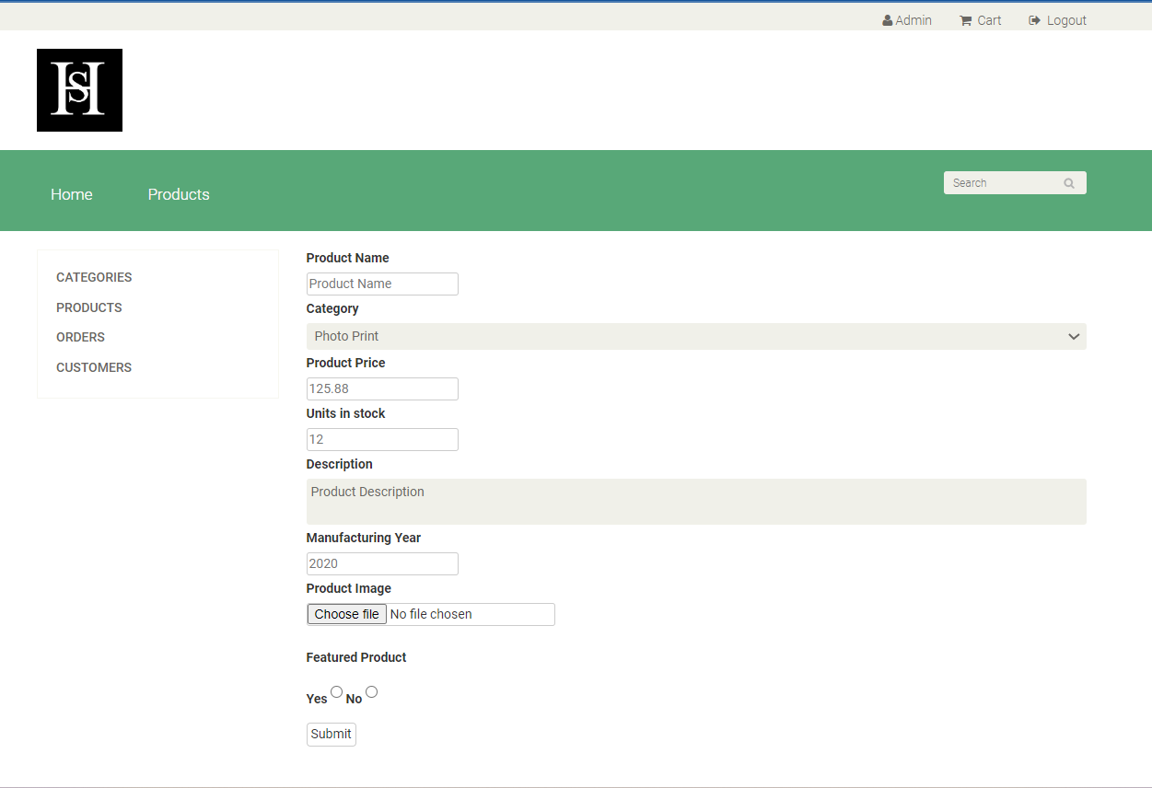

**Figure 4.2.6.(b)admin add new category/product page**

## ADMIN UPDATE STATUS OF PRODUCT PAGE:

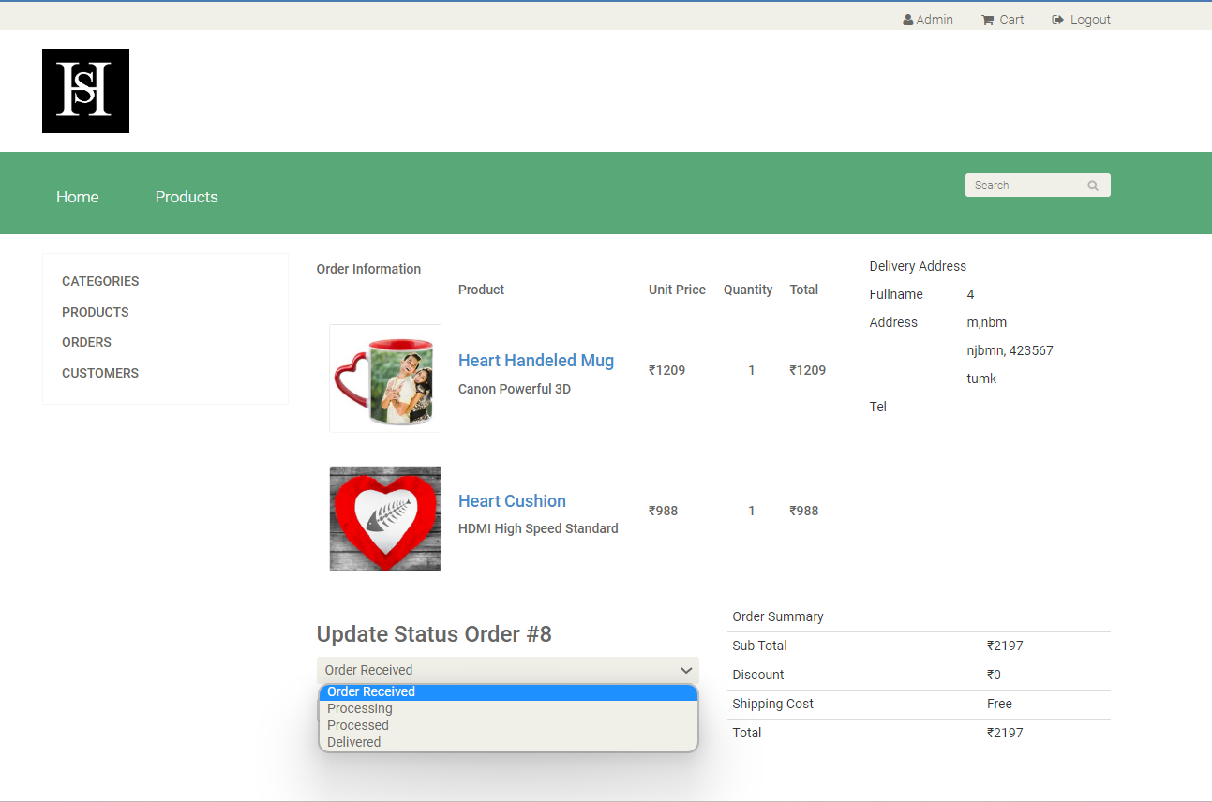

**Figure 4.2.7.admin update status of product page**

4.3.USER PAGE :

**CUSTOMER PERSONAL INFO :**

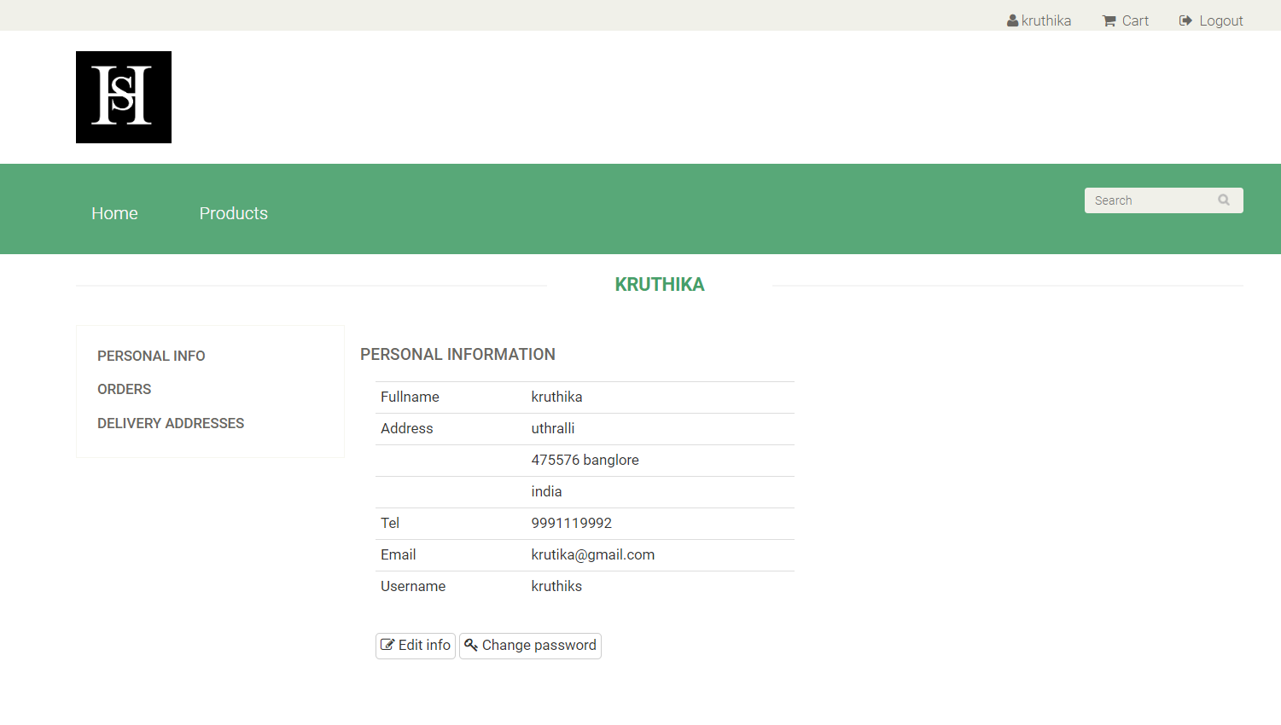

**Figure 4.3.1.customer personal info**

**ADDRESS PAGE:**

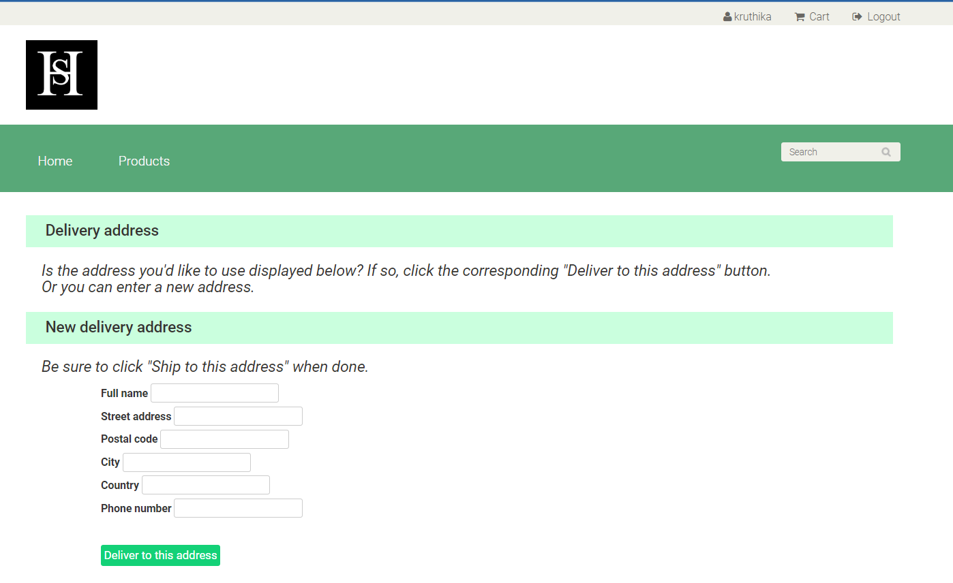

**Figure 4.3.2.address page**

## USER CART PAGE:

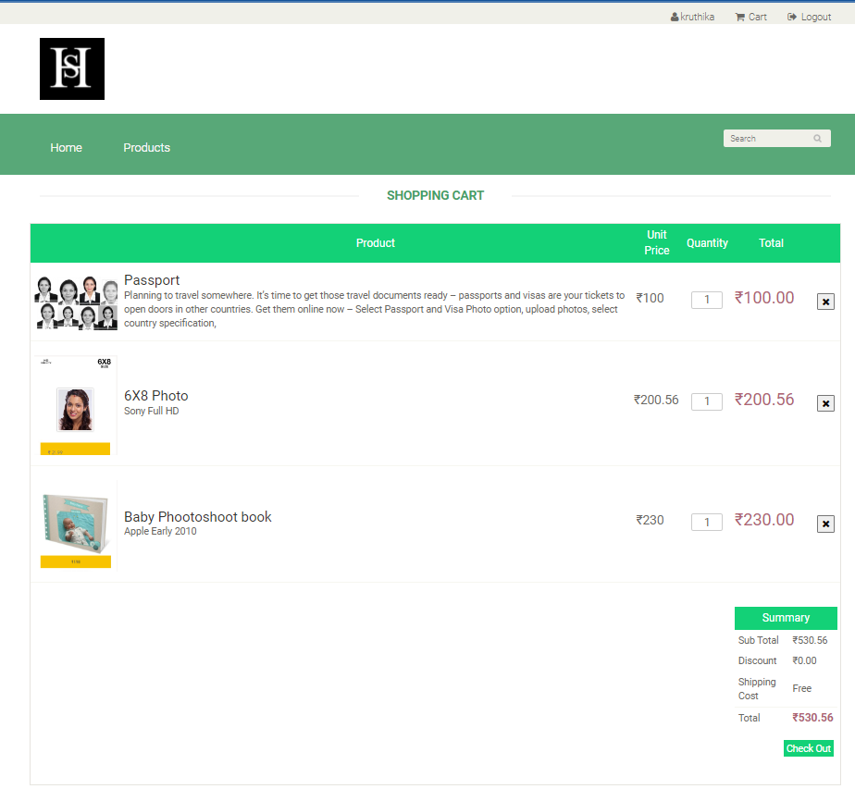

**Figure 4.3.3.user cart page**

## USER REVIEW ORDER PAGE:

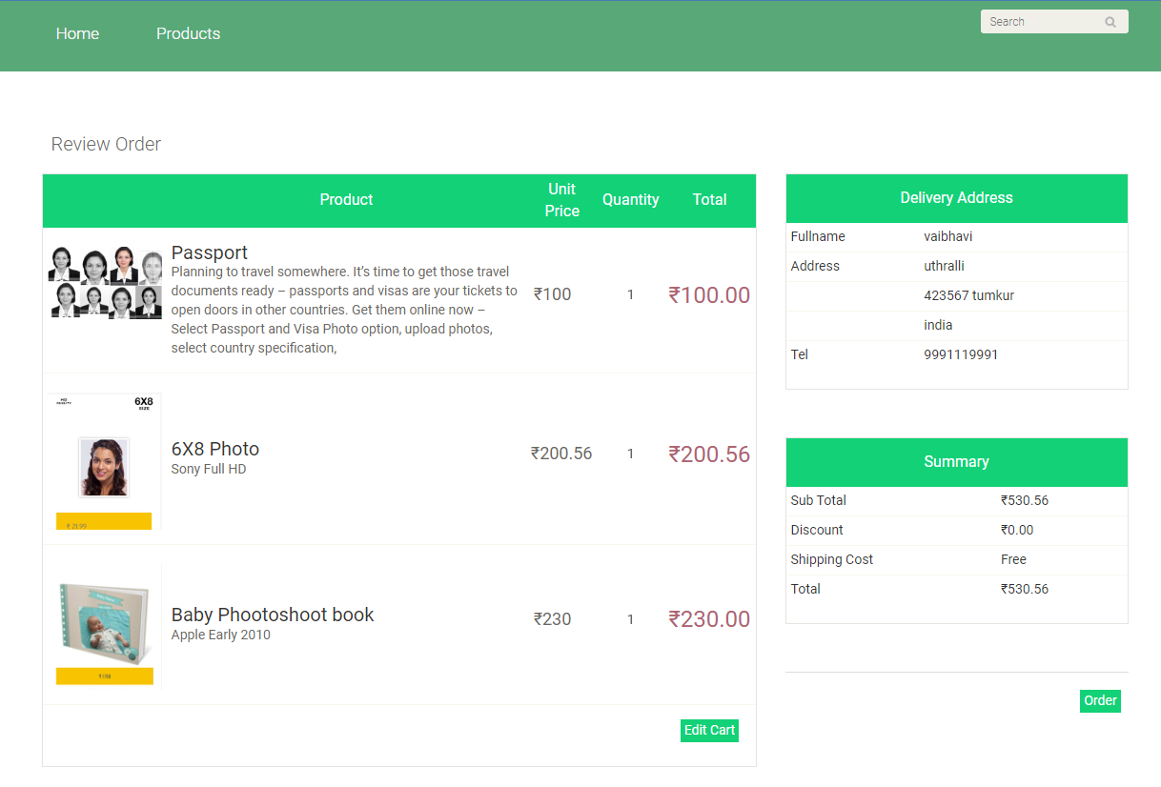

**Figure 4.3.3.user review order page**

## ORDER PLACED PAGE:

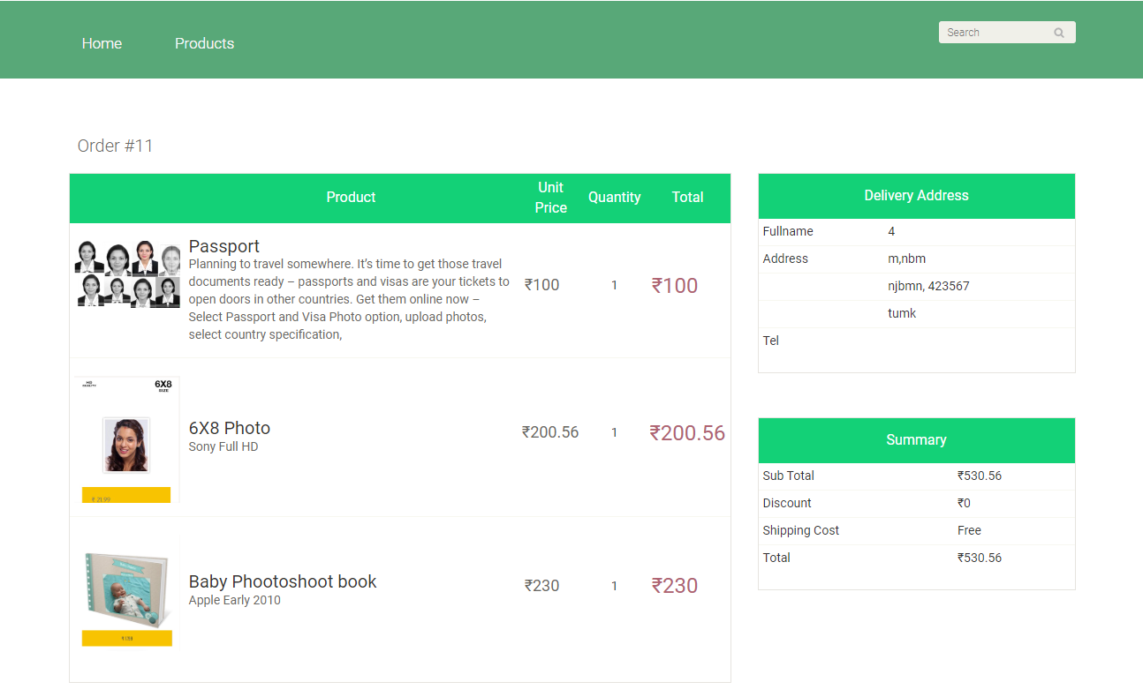

**Figure 4.3.3.order placed page**

**USER ORDER_DETAILES PAGE:**

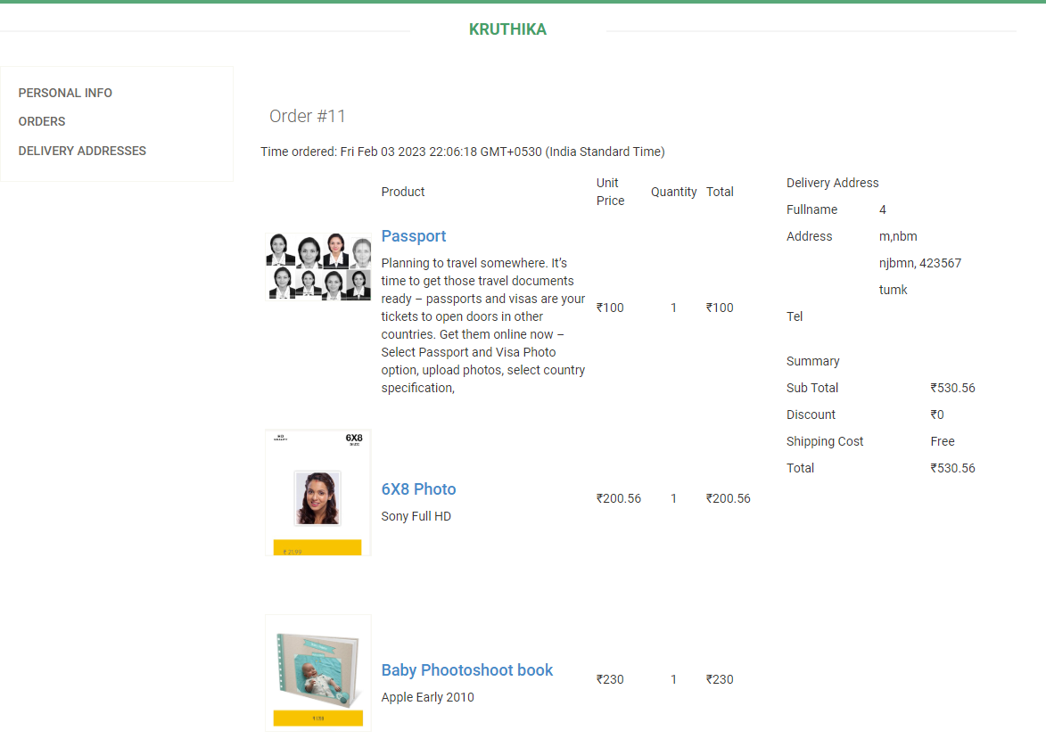

**Figure 4.3.4.user order_details page**

**ORDER HISTORY PAGE:**

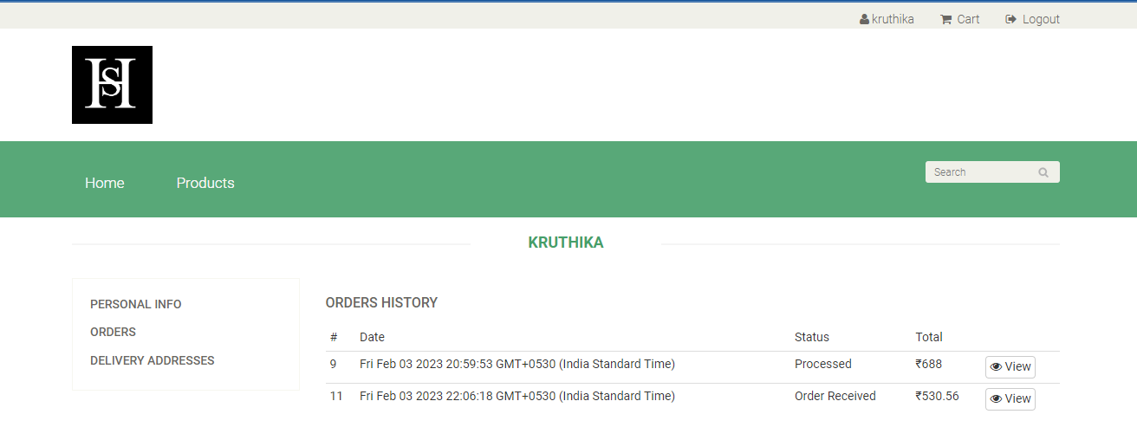

**Figure 4.3.4.order history page**

**CHAPTER-4**

**CONCLUSION**

The project entitled Online Photo Shopping was completed successfully. The system has been developed with much care and free of errors and at the same time it is efficient and less time consuming. The purpose of this project was to develop a web application for purchasing items from a shop.This project helped us in gaining valuable information and practical knowledge on several topics like designing web pages using javascript, Html & css, usage of responsive templates, designing of android applications, and management of database using mysql . The entire system is secured. Also the project helped us understanding about the development phases of a project and software development life cycle. We learned how to test different features of a project. This project has given us great satisfaction in having designed an application which can be implemented to any nearby shops or branded shops selling various kinds of products by simple modifications. There is a scope for further development in our project to a great extend.

A number of features can be added to this system in future like providing moderator more control over products so that each moderator can maintain their own products. Another feature we wished to implement was providing classes for customers so that different offers can be given to each class. System may keep track of history of purchases of each customer and provide suggestions based on their history. These features could have implemented unless the time did not limited us.

**REFERENCES**

• **TEXTBOOK:**

Database management system by ramakrishnan.

Fundamentals of database system by Ramez Elmarsi, Navathe.

**• NODE JS:**

“https://www.w3schools.com/js/js_string_search. asp”

“<https://www.javatpoint.com/javascript-tutorial>”

“<https://www.javatpoint.com/nodejs-tutorial>”

“<https://www.javatpoint.com/jquery-tutorial>”

• **MYSQL:**

“https://www.w3schools.com/sql/default.asp”

“<https://www.javatpoint.com/sql-tutorial>”

• **HTML /CSS:**

“<https://www.javatpoint.com/css-tutorial>”

“https://www.javatpoint.com/html-with-css”

“https://www. w3schools.com/css/default.asp”

“https://www. w3schools.com/html/default.asp”

“ <https://developer.mozilla.org/en-US/docs/Learn/HTML/Tables/Basics>”